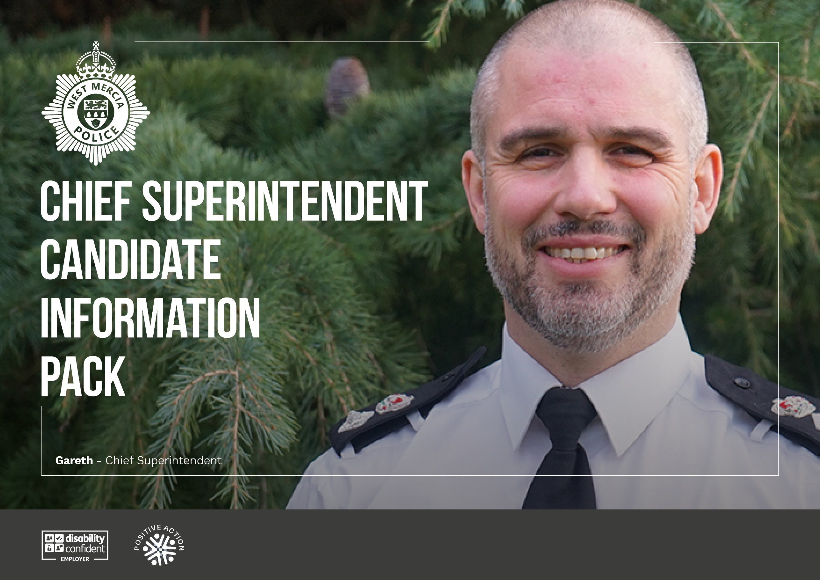

Welcome
Thank you for your interest in applying for the role of Chief Superintendent at West Mercia Police.
Our vision is to be a people led, tech enabled, crime fighting service.
We want your ambition and passion to help us progress in all these areas. If you’re looking for a great place to work, to be empowered to make a difference to your teams, and to achieve real fulfilment in your career, then West Mercia is for you. West Mercia offers the complexities and interest of both urban and rural policing; it can be both beautiful and challenging.
To support me and my colleagues in this aim, I am looking for resilient, dynamic and inspirational leaders who can help drive the force forward in times of continuing change and deliver effective policing services to the communities of West Mercia.
You must demonstrate a strong commitment to being visible and accessible to both our people and partners in West Mercia.
Thanks for considering West Mercia Police. If successful you will have my full support.
I want you to bring your ideas and you will be empowered to lead.
If you would like an informal discussion on any aspects of the role with me or my team, please contact Rachel Hartland-Lane, Director of Business Services:
- rachel.hartland-lane@westmercia.police.uk
I wish you every success in your application, you won’t regret it.


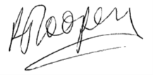
Richard Cooper
Temporary Chief Constable

Click to read the Safer West Mercia Plan:
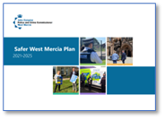
Click to read our Community Charter:
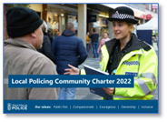

Have a look at some of our recent crime-fighting and community engagement work:

- A year in review 23/24
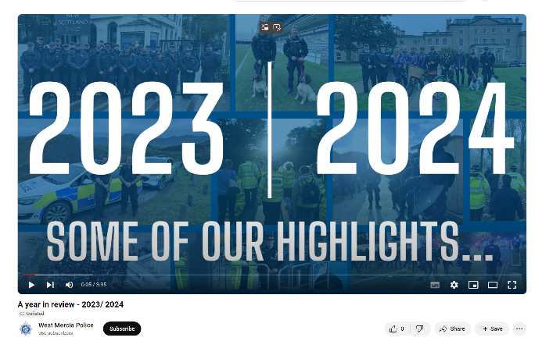
- Drugs/cash/property seized in raid:
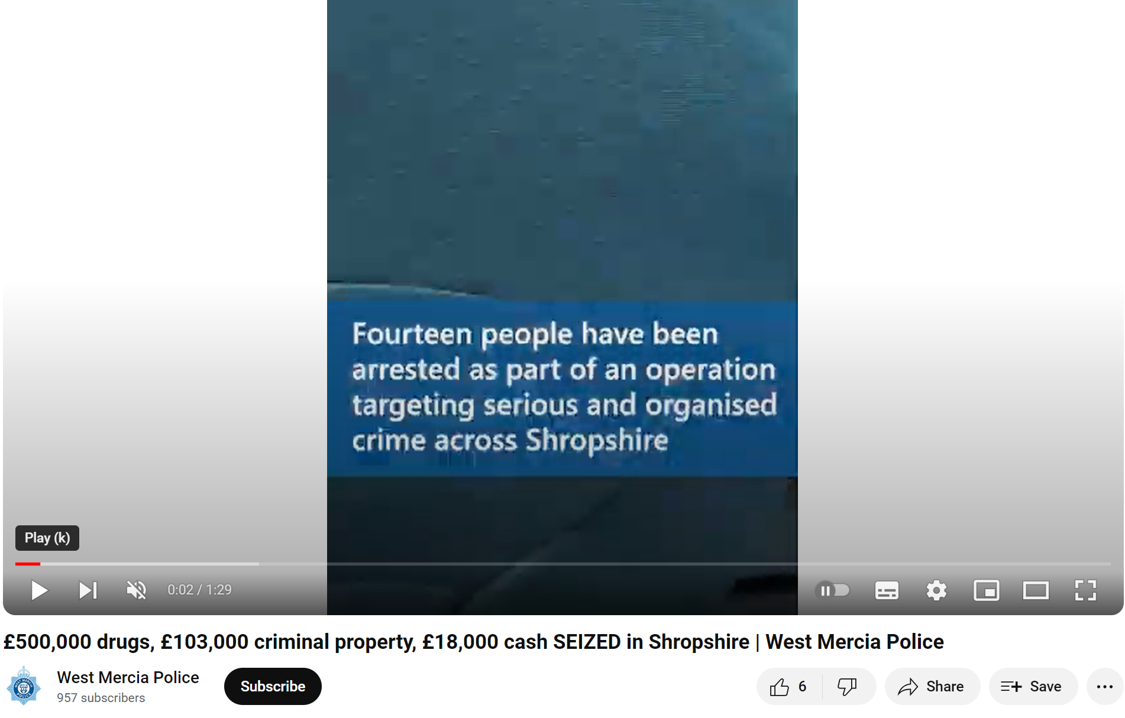
- Op Forefront – day of police action:
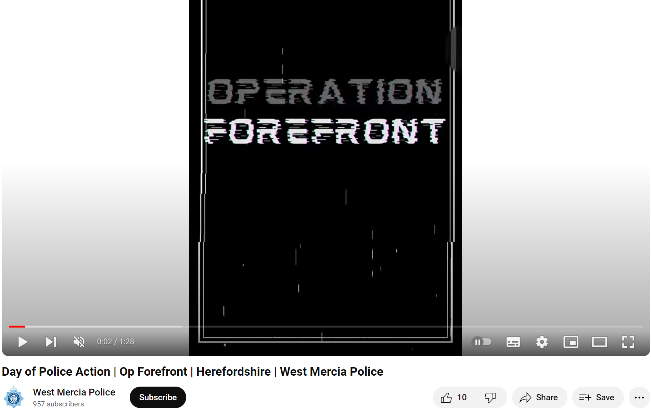
- Walk and Talk - Telford
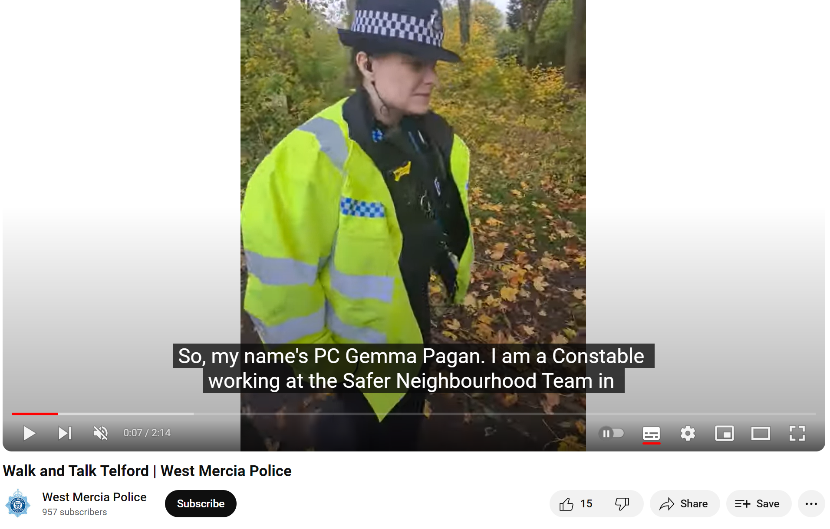
- When I Grow Up by Bea Moore:


See how we celebrate our officers, staff and volunteers:
- Quality Policing Awards evening:


The Chief Superintendent role
The Chief Superintendent will be part of the senior management team supporting the Chief Constable in delivering our Vision and Values, Service and Leadership Ethos and Policing Priorities by ensuring we are an organisation which engages with an inclusive workforce and has health and wellbeing of our people at the heart of the service.
You will ensure through effective leadership and engagement of partners, stakeholders and members of the public, that policing is effective, economic and efficient in its delivery of agreed outcomes.
The role requires a leader with energy, personal drive, compassion and authenticity who can help drive the force forward. The ideal candidate will be passionate, driven and operationally strong with a proven track record in leading significant change, delivering high performance and positive outcomes for the community.
Applicants must be a Chief Superintendent or current Superintendent with substantial knowledge of contemporary policing issues, proven experience of strategic performance management and an outstanding track record of delivering successful change for improved service to the public. You must be a good team player demonstrating a strong commitment to being visible and accessible to both our people and partners in West Mercia.
You will contribute to strategic development, set standards and operational policy as well as authorise operational activity for the teams under your leadership.
You will work closely with your Chief Superintendent colleagues prioritising the needs of our communities.
West Mercia also holds three senior leaders’ events throughout the year, chaired by the Chief Constable. These are focused on delivering impactful inputs on key issues for the force based on the time of the year.

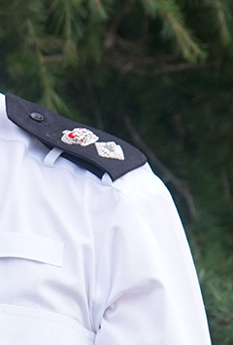

Life at West Mercia Police …
Chief Superintendent Gareth Morris

How long have you been in policing?
I joined West Mercia Police in October 2023 as a transferee from West Midlands Police, which is where I began my policing career. I’ve had the privilege of working in various roles including MOSOVO/MAPPA, FIM, and the Operational Support Unit as a PolSA and Level 1 Public Order officer.
I also served as an Inspector for Birmingham City Centre and later as a Superintendent and was the lead for the force’s approach to tackling youth violence and knife crime.

What is the best thing about working in West Mercia Police?
The best thing about working in West Mercia Police is the genuine sense of support that exists within the force. There’s a strong foundation of peer support, and the Executive Team are approachable and willing to listen. The force is ethically driven, which fosters an environment where people feel confident speaking out and doing the right thing.
From a career perspective, the force offers a broad variety of challenges, with the unique opportunity to work across both urban and rural communities. Additionally, there are opportunities to take on Gold duties and command portfolios, making West Mercia an excellent place for professional growth.

What advice would you give to anyone looking to join West Mercia Police?
For anyone considering joining West Mercia Police, my advice would be to take the time to explore the geography and communities we serve. It’s also important to speak to current staff members, including representatives from the Federation and Union, to gain a deeper understanding of the support and opportunities available.

About West Mercia Police
West Mercia is the fourth largest geographic police area in England and Wales, covering 2,868 square miles. Our communities cover three counties: Herefordshire, Shropshire (which includes Telford & Wrekin) and Worcestershire with more than 1.3 million people living in the areas we serve.
Whilst many of our communities are rural there are significant urban areas and small areas of social deprivation that are among the 10 percent most deprived areas nationally.
The force has been actively recruiting additional officers to meet its new, increased establishment of 2,496 in 2023/2024, the highest level on record in the force. We also have 200 PCSOs, more than 1,700 members of police staff and dozens of volunteers (including the Special Constabulary).
Numbers of officers have significantly increased year-on-year through both national uplifts and local initiatives. This ambitious level of recruitment is already positively impacting our communities.
The force is divided into five policing areas, each headed by a superintendent, and further divided into local safer neighbourhood teams made up of officers and staff who work within the communities. Other departments include Criminal Investigations Department (CID), Professional Standards Department (PSD), Forensics and Operational Patrol Unit (OPU), including roads, dogs and firearms.
All these areas of the business are supported by professional teams including HR, IT and Corporate Communications.
Financial reports from the PCC are available on the link below:
- Financial Reports - West Mercia Police Crime Commissioner (westmercia-pcc.gov.uk)

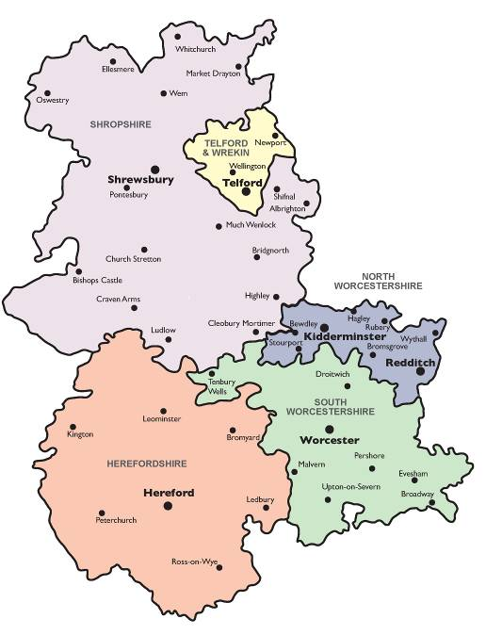

Who we are
West Mercia Police is led by our Chief Officer team:
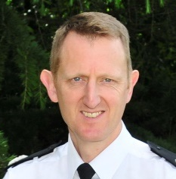 | 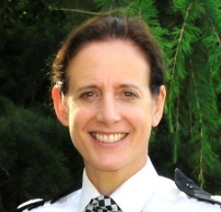 | 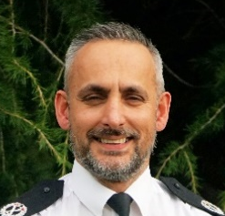 | 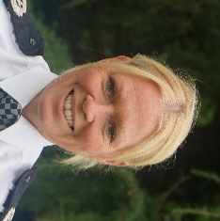 |  | 
T/Chief  Constable  Richard Cooper | T/Deputy Chief Constable  Rachel Jones | Assistant Chief Constable  Grant Wills | T/Assistant Chief Constable  Caroline Marsh | Director of  Business Services  Rachel Hartland-Lane | Director of  Commercial Services  Richard Muirhead

Policing area leads:
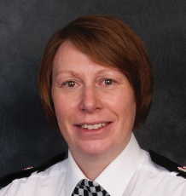 |  | 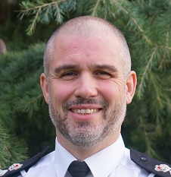 | 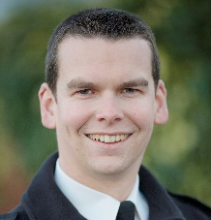
Chief Superintendent  Beth Bridges | Chief Superintendent  Crime & Vulnerability  Mel Crowther | Chief Superintendent  Operations Support  Gareth Morris | T/Chief Superintendent  Local Policing  Edd Williams

Force vision and values
Our vision, values and policing priorities are the thread that runs through the fabric of our organisation.
Our vision is to be a people-led, tech-enabled, crime fighting service.
All force officers, staff and volunteers are expected to live by these values day in, day out and underpinned by the Code of Ethics. All of the above are at the forefront of the force’s priorities, plans and daily work.
In a recent survey of more than 3,000 local people, 94% stated that West Mercia Police has their support, and 89% have trust in the force. Overall, public confidence in West Mercia Police currently stands at 82%.
64% of residents think their police force are doing a good or excellent job, and 71% believe that West Mercia Police understand the issues in their community.

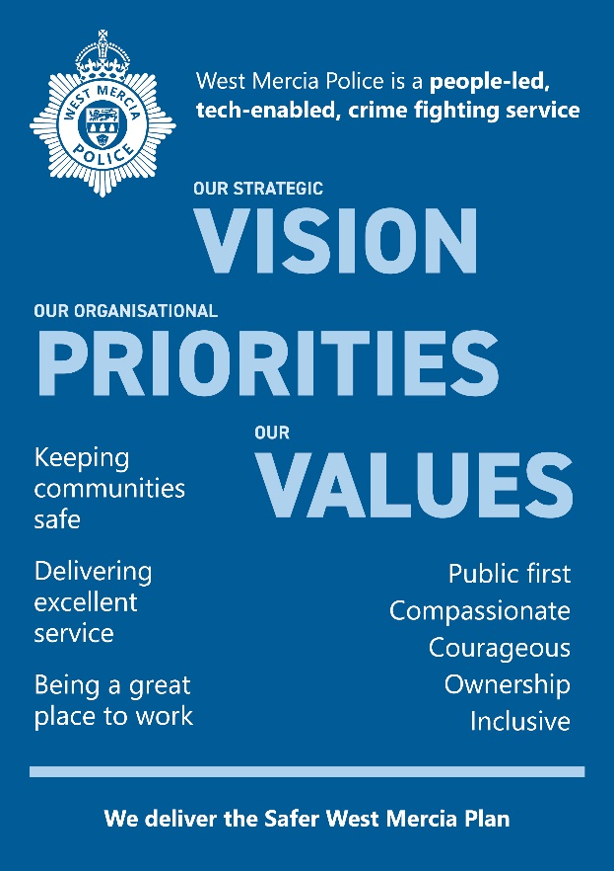

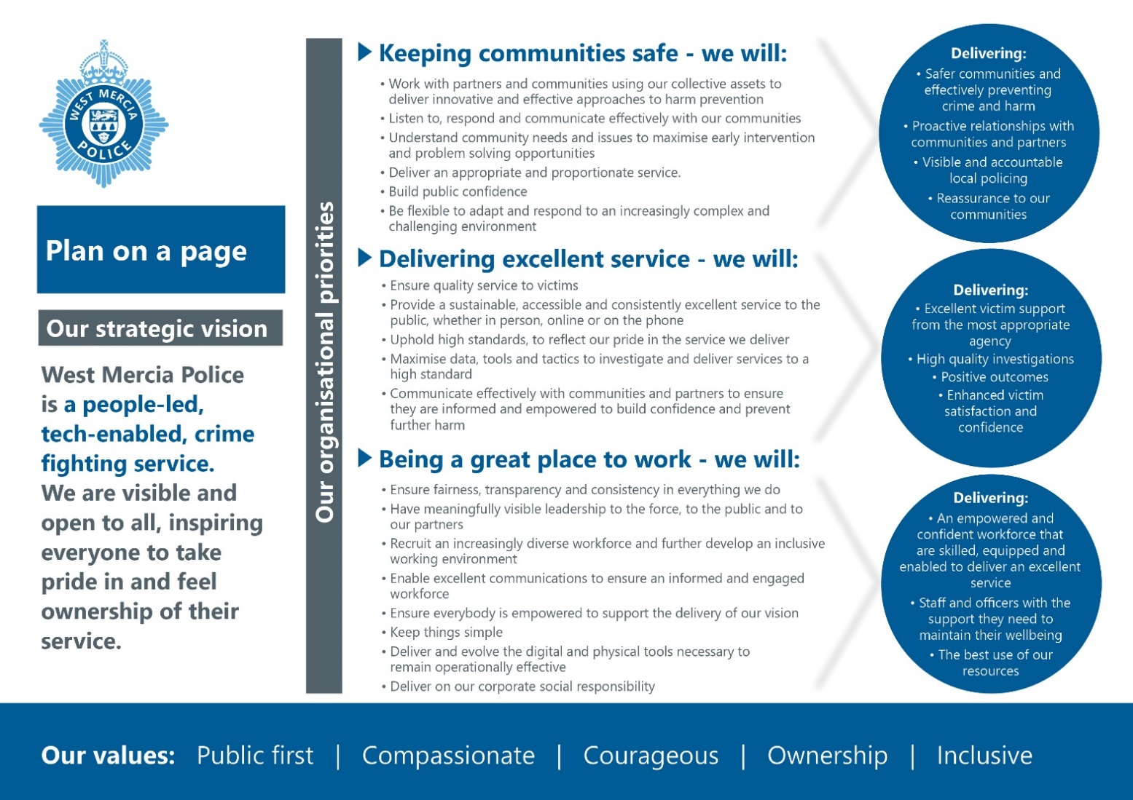
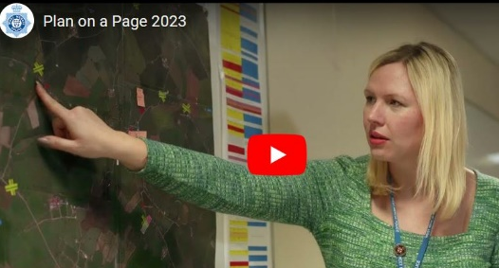

Video showcasing our Plan on a page commitment, that outlines our new strategic priorities, vision and values.

Policing West Mercia
Information relating to the policing of West Mercia Police can be found on our website:
- http://www.westmercia.police.uk/
West Mercia Police has a Local Policing Community Charter, which makes commitments of service to local communities. This can be found here:
- West Mercia Police | Local Policing Charter | West Mercia Police

Change
We know that policing is changing. What is understood as traditional policing has already changed dramatically and will continue to do so. We need to be able to respond to that change and as technology continues to speed up social evolution, it is vital that we work with greater agility in future. Added to this, we must operate within the constraints of public spending, and this will continue to be challenging.
Our focus is on becoming as efficient and effective as we can possibly be, right now and for the future. We can and will embrace a different style, culture, and approach to achieve a new and modern way of delivering policing.
Positive change is already underway, with hot spot policing and focussed deterrence initiatives, investment in Rapid Video Response in our Operational Control Centre and the introduction of new ways to engage with our workforce using the latest technology available to us. Significant improvements are also being made to our estate with a brand-new station due to open in Redditch and a new firearms training centre at headquarters, featuring a 50-metre indoor range, a building search facility training area and a training school.

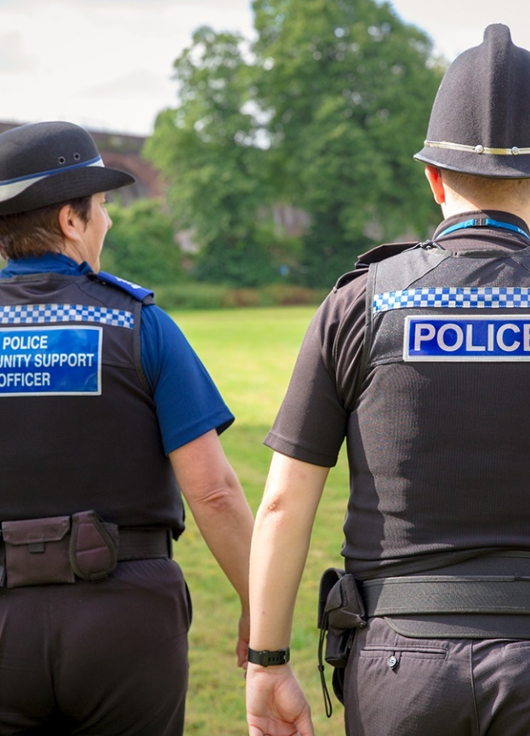

People strategy
In order to meet the challenges of the next few years, our organisational change will look to maximise the quality and effectiveness of our policing output in order to protect people from harm. This will be delivered by ensuring the right people are in the right place at the right time, with the right skills and attitude to deliver.
The force’s policing model and the shape and size of our organisation continues to change whilst demands continue to increase. It is therefore vital that we shape our workforce and environment to meet such challenges.
Recruiting and retaining the right people and maximising the contribution each and every person makes, is more critical than it has ever been to achieve the vision and support the delivery of our service.
West Mercia launched its new People Strategy in 2020 with the focus of enabling our people to be the best they can be. The strategy has six core objectives:
- Building strong, confident, and compassionate leadership.
- Ensuring personal resilience.
- Focused development.
- Attracting and managing talent.
- Effective workforce planning.
- Building a professional workforce.

West Mercia Police seeks to develop and enable our leaders to achieve the best for themselves and their people, by recognising and nurturing talent for the future.
The force is committed to creating an inclusive environment where our people feel empowered to exercise professional judgement, utilise their emotional intelligence and feel comfortable and confident to challenge. Ensuring our people have the confidence and capability to deliver our vision and values by developing effective leadership qualities is pivotal. We want our people to feel part of an organisational culture where they can be themselves, a culture that values diversity for the greater benefit of our communities.
We also support the National College of Policing leadership dimensions which we will endeavour to instil and develop at every level.
We invest in our people in a variety of ways which add value in order to develop a skilled, efficient, and effective workforce that reflects the changing needs and demands of the police service.
Our vision and values are underpinned by a learning culture which embeds personal responsibility and continuous improvement in our people and the service we deliver.

Support networks
We all have different needs, so we are proud to offer a range of support groups including; the B-ME network which offers peer support and mentoring as well as help with job applications and interviews, the Disability Network which includes specific groups for disability, dyslexia, hearing impairment, PRIDE in West Mercia and Women of West Mercia (WOW).

Occupational Health
Occupational health is a team focusing on the health of officers and staff in the workplace. Their aim is to keep people happy and healthy at work.

Employee Assistance Programme
Our employee assistance programme is available to all officers and staff and provides 24/7 access to a range of services to support personal health and wellbeing. Impartial and confidential support is available, including assessment, advice and signposting for both work and non-work-related matters.

Peer Support
Peer Supporters are colleague volunteers who support colleagues with their mental wellbeing. They come from all areas of business and at all ranks.

Welfare
The Welfare Officer Team provides welfare support to individuals and managers across the force. They act as the first point of contact to provide confidential triaging and appropriate professional advice and recommendations in relation to any issues both personal and professional, affecting the psychological wellbeing of both officers and staff.

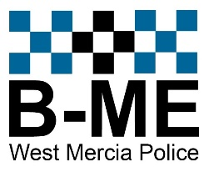











Diversity, Equality, and Inclusion Interim Strategy
2024-25
As Chief Constable, it is important to me to start with why and to articulate the rationale behind prioritising inclusivity within our organisation. This rationale can be distilled into two primary reasons. Firstly, there is simply a moral imperative to look out for each other to ensure that everyone feels welcome, fostering good workplace relationships with everybody.
Secondly, and just as importantly, there is real value in diversity. Fighting crime and embracing diversity are two sides of the same coin. If we don't treat all communities well there will be an absence of trust, and if there's an absence of trust people don't cooperate with the police, they don't comply with the police, they won't give statements, and they certainly don't empower the police to do a very difficult job. There will always be suspicion.
There is also a strength of evidence that shows the people who think differently from different backgrounds can provide a more sophisticated perspective on how we operate - our policies, our processes, our strategy, and our tactics. And it goes without saying that a workforce that looks out for each other is going to be a better and more productive place to work.
All of these reasons come together to make a very strong case for why we should think long and hard about how we can be as inclusive as possible.
As senior leaders within West Mercia Police, we are collaborating with our leadership teams across all organisational levels to elevate the inclusivity, responsiveness, and efficacy of our policing services.

Click to read the strategy:


The Strategy
Our overarching objective is to achieve policing excellence for all of our communities. This interim Strategy is designed to strengthen our capability to deliver a policing service that is effective, trusted, fair, and equitable, protecting all communities from harm while actively engaging and consulting to understand priorities and concerns. It seeks to establish frameworks that ensure the integration of diversity, equality, and inclusion into all aspects of our decision-making, policies, and operational procedures, creating and retaining an engaged workforce that is representative of our diverse communities.
Our interim Strategy aligns with other diversity, equality, and inclusion initiatives such as the Police Race Action Plan and Purple Spaces Plan, showcasing our dedication to becoming an anti-racist organisation and upholding our Disability Confident Level 3 status. In 2022, we incorporated ‘Inclusive’ as our fifth core value, and in light of this milestone and subsequent organisational developments, we have developed this interim Strategy.
West Mercia Police serves approximately 1.3 million people. Promoting equality of opportunity and celebrating diversity is a fundamental enabler of our overarching vision ‘deliver a quality policing service and to protect people from harm’. It is intrinsic to our organisational culture, underpins our objectives and helps shape the way in which our services are designed and delivered.
The force is committed to serving our communities and our people, taking into consideration, and listening carefully to our many stakeholders.
We have also added inclusion as our fifth value.







What our people say about working here

Laura, Operations and Communications Centre Supervisor
- I have been a supervisor for over three years, and I can honestly say I love my job. I have a really good team; no day is ever the same and I feel satisfied that we are protecting members of the public every day.”

Rebecca, Police Constable
- The people are the best thing about my job. It’s a cliché, but they really are like a second family. I didn’t appreciate that aspect until I became an officer. It’s amazing, you get to work together but we also do so much outside work - some people in the team are my best friends, and they really are friends for life.”

Gabrielle, Motor Vehicle Technician Apprentice
- My work colleagues are very encouraging and supportive with my aspirations and progress.
I am happy with my job and enjoy coming to work, to improve my knowledge.”


What the public thinks of us
In a recent survey we found that:
94%
of people surveyed stated that West Mercia Police has their support

85%
of people are confident that they would receive a good service from us
We can, of course, improve on this and maybe you can help us do that!

Feedback – why we do what we do
Working for West Mercia Police means the work you do often directly helps members of our local communities.
Whether you work in our operations and communications centre and answer lifesaving calls, work in one of our local safer neighbourhood teams and return someone’s cherished possessions, or work in our communications team and share a story that helps locate a missing person.
People appreciate the help they are given, and often want to make their appreciation known. Here are some of those comments we have received since the beginning of 2023.

Feedback given to police officers after attending the scene of a crime:
- The statement was taken in great detail with a very high degree of both professionalism and sensitivity. What could have been a harrowing experience was made as positive and easy as possible. I really do think they deserve a wholehearted thank you.”

Feedback given to police officers after a successful case:
- During this awful experience every member of the police have been so kind to us, and so communicative, letting us know what they were able to tell us, my wife and I are just so impressed with this police force it makes us feel safe. All involved in this incident need to be thanked for all their hard work. I cannot praise the officers involved enough and I thank them very much indeed for all they have done for us.”

Feedback given to an OCC contact handler:
- The police operator dealing with a very difficult abusive lady, demonstrated outstanding skills, patience and professionalism. Both my wife and I would like it noted that she played an exceptional role in dealing with the situation and we would like to thank her accordingly.”

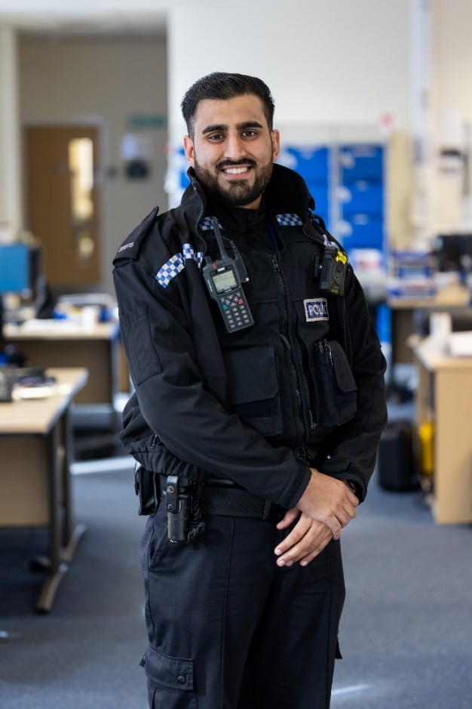

Feedback given to police officers and support staff following a theft:
- Thank you, and your colleague, for visiting last week. I have made use of the support pack you gave me. I have signed up to Neighbourhood Matters, logged my computer equipment on the immobilise website and registered the SmartWater. I will begin applying it later.”

Feedback given to support staff:
- For excellent service in renewing my shotgun certificate.”

Feedback given to officers who attended a burglary:
- Amazing rapid response and resolution to a burglary. At all times courteous, efficient, and supportive. Could not fault the response. Exemplary.”

Feedback given to officers who successfully dealt with a dog straying onto train tracks:
- There were initially four officers dealing with my sister's dog straying onto the railway line. They were professional, courteous non-judgmental. My sister and I cannot thank them enough.”

Feedback given to police officers who attended and settled a disruption before it could develop:
- Well done to the officers who responded so quickly in the wee small hours of this morning, to an incident in Redditch. Four young men were engaged in a very heated argument in the middle of the road, and it had the potential to get out of hand. Your officers immediately calmed the situation down and dealt quietly with the young man who had been seriously provoking the other three. Good job!”
