Sergeant

Information pack

August 2023



Message from the Chief Constable
Thank you for expressing an interest in applying for the role of Sergeant for West Mercia Police.
This is an exciting time to join West Mercia Police as we reshape our future. You will work closely with me to ensure that we effectively delivery our ambitious vision.
I am committed to delivering an outstanding police service that is sustainable for the long term, provides the best possible protection to our communities and is a great place to work for our officers, staff and volunteers. To support me and my colleagues in this aim I am looking for resilient, dynamic and inspirational leaders who can help drive the force forward in times of continuing change and deliver effective policing services to the communities of West Mercia.
You will be people focused, operationally strong and a good team player with a proven track record in leading teams to achieve organisational priorities.

You must demonstrate a strong commitment to being visible and accessible to both our people and partners in West Mercia.
I wish you every success in your application.

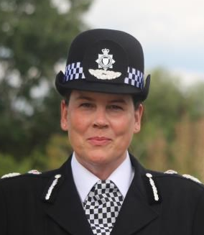
Pippa Mills
Chief Constable
West Mercia Police

General information
West Mercia is the fourth largest geographic police area in England and Wales, covering 2,868 square miles. Our communities cover three counties: Herefordshire, Shropshire (which includes Telford & Wrekin) and Worcestershire with more than 1.3 million people living in the areas we serve.
Whilst many of our communities are rural there are significant urban areas and small areas of social deprivation that are among the 10 percent most deprived areas nationally.

The force has been actively recruiting additional officers to meet our establishment of 2,456. We also have 222 PCSOs, over 1800 members of police staff and over 325 special constables and volunteers.
Notwithstanding the national increases which Operation Uplift promises, this ambitious level of recruitment is already positively impacting our communities.
This significant uplift in officers will take the force to its highest number since 2012.

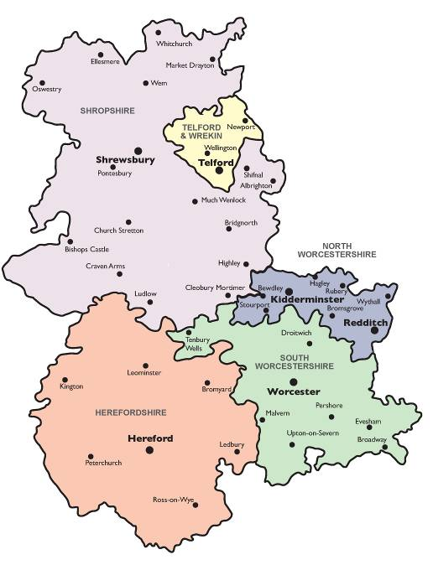 | Policing Plan and Budget Information  A copy of the Police and Crime Plan, Budget Report and other key documents are available on the following websites:  http://www.westmercia.police.uk/  http://www.westmercia-pcc.gov.uk/key information

Our vision and values and
Plan on a page
The thread that runs through the fabric of our organisation is our Vision and Values and our Policing Priorities.
As a force we have a track record that demonstrates that we live by these values day in and day out, underpinned by the Code of Ethics. Our Plan on a page should be at the forefront of our priorities and all the work we do.

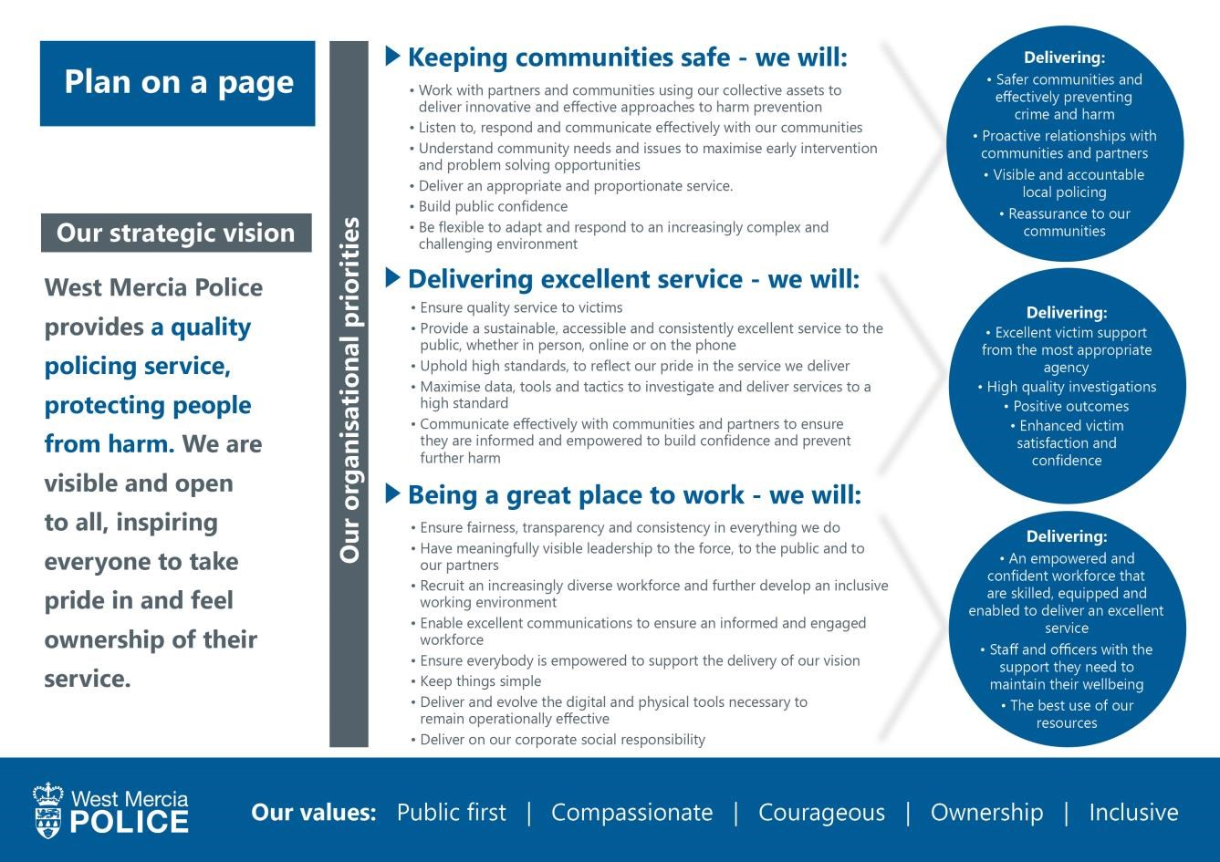

We are proud that a recent survey of more than 3000 local people, 93% stated that West Mercia Police has their support, with 84% confident that they would receive a good service.
Our aim is to further improve on these figures by keeping a clear focus on delivering a quality policing service and protecting people from harm, through demonstrating our core values of putting the public first, taking ownership, acting with courage and compassion and ensuring we are an inclusive force.

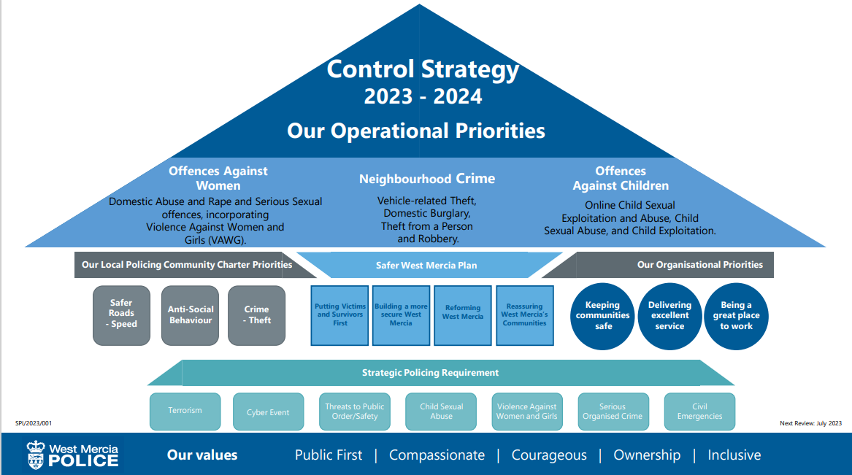

Policing West Mercia
Information relating to the policing of West Mercia Police can be found on our website http://www.westmercia.police.uk/

Preventing and detecting crime
Building on the innovative approach to early help and prevention, our ambition is to bring crime down and improve detection rates. Sound foundations are in place to continue to improve investigations including supervision to ensure a quality service is provided to victims of crime. Strong leadership is vital to ensure our performance positively informs victim satisfaction and public trust and confidence.

Change
We know that policing is changing. What is understood as traditional policing has already changed dramatically and will continue to do so. We need to be able to respond to that change and as technology continues to speed up social evolution, it is vital that we work with greater agility in future. Added to this, we must operate within the constraints of public spending and this will continue to be challenging.
Our focus is on becoming as efficient and effective as we can possibly be right now and for the future.
We need to embrace a different style, culture and approach to achieve a really new and modern way of delivering policing.

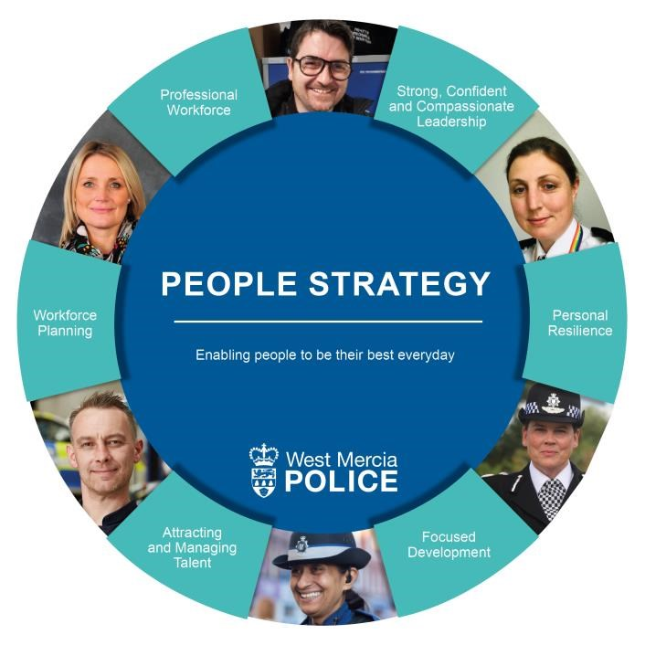

People strategy
In order to meet the challenges of the next few years, our organisational change will look to maximise the quality and effectiveness of our policing output in order to protect people from harm. This will be delivered by ensuring the right people are in the right place at the right time, with the right skills and attitude to deliver.
Our policing model and the shape and size of our organisation continues to change whilst demands continue to increase. It is therefore vital that we shape our workforce and environment to meet such challenges.
Recruiting and retaining the right people and maximising the contribution each and every person makes is more critical than it has ever been to achieve the vision and support the delivery of our service.
West Mercia launched its People Strategy in 2020 with the focus of enabling our people to be the best they can be. The strategy has six core objectives:
- Building strong, confident and compassionate leadership.
- Ensuring personal resilience.
- Focused development.
- Attracting and managing talent.
- Effective workforce planning.
- Building a professional workforce.
West Mercia Police seeks to develop and enable our leaders to achieve the best for themselves and their people, by recognising and nurturing talent for the future.
We are committed to creating an inclusive environment where our people feel empowered to exercise professional judgement, utilise their emotional intelligence and feel comfortable and confident to challenge. Ensuring our people have the confidence and capability to deliver our vision and values by developing effective leadership qualities is pivotal. We want our people to feel part of an organisational culture where they can be themselves, a culture that values diversity for the greater benefit of our communities.
We also support the National College of Policing leadership dimensions which we will endeavour to instil and develop at every level.

We invest in our people in a variety of ways which add value in order to develop a skilled, efficient and effective workforce that reflects the changing needs and demands of the police service.
Our vision and values are underpinned by a learning culture which embeds personal responsibility and continuous improvement in our people and the service we deliver.

Health and wellbeing
The health and wellbeing of our staff is extremely important. We will ensure that the workforce understands their role in maintaining a healthy and safe working environment to protect themselves, their colleagues and the public we serve.
We recognise that it is our people who will deliver our vision of protecting people from harm. We know that when our officers and staff are feeling well and satisfied with their work it will have a positive benefit for the communities we serve.
We need to build on the good work we have achieved so far to ensure that the wellbeing of our workforce is fully embedded within everything we do.
Diversity and inclusion
West Mercia Police serves approximately 1.3 million people. Promoting equality of opportunity and celebrating diversity is a fundamental enabler of our overarching vision ‘to protect people from harm’. It is intrinsic to our organisational culture, underpins our objectives and helps shape the way in which our services are designed and delivered.
The force is committed to serving our communities and our people, taking into consideration and listening carefully to our many stakeholders.

Our statutory duty
We are ever mindful of our duties under the Equality Act 2010 which is the UK’s discrimination law that protects individuals from unfair treatment and promotes a fairer and more equal society. The Act protects people from discrimination, harassment and victimisation in work, education and when accessing services.
In addition the Public Sector Equality Duty
(PSED) came into force across Great Britain on 5 April 2011. It means that public bodies have to consider all individuals when carrying out their day-to-day work - in shaping policy, in delivering services and in relation to their own employees.
Our aim is to increase trust and confidence and our approach is to empower communities to actively participate in delivering a fair and accessible police service for all.
Our equality objectives 2021 - 2025
Our communities:
- Understanding our communities: We will continue to enhance this through engagement and equality data and analysis. This helps us to better understand the composition of our communities and help us to see any patterns of inequality or disparity.

- Engagement and good relations: We develop our engagement work with diverse communities and continue to work with our Independent Advisory Groups.
- Increasing confidence: We will be open and transparent as we build relationships with diverse groups, inviting scrutiny of information about important issues such as the use of force; stop and search; custody; hate crime and victim satisfaction.
Our partners:
- Understanding the Partnership Landscape: Through partnership working with, e.g. other Criminal Justice System agencies, Local Authorities, NHS or voluntary sector partners, where relevant, we will analyse information that highlights disparity in the services we offer and work collectively to place the needs of victims and service users at the heart of our work.
- Tackling Disparity: With our partners we will explain, where necessary reduce or eliminate disparity and improve services.
- Joint Services Delivery: We will work with partners to develop strategies that provide effective public services in our communities, particularly for those who are vulnerable to crime and to involvement with the criminal justice system.
People and culture:
- Transparency & Scrutiny: We will make our organisation as transparent as possible and encourage scrutiny of our activities by Staff Networks, Independent Advisory Groups and other stakeholders. This increased level of scrutiny will ensure we are responsive to feedback to improve our service. We will publish required equality data.
- Developing our workforce: We will develop all our officers and staff so that they have a strong awareness of how equality, diversity and inclusion supports us to achieve a positive, dynamic working culture and a truly effective police service.
- Understanding our workforce: We will improve our understanding of the makeup of our workforce by putting systems in place to better analyse equality addressing any underrepresentation or disproportionality through innovative recruitment, retention and progression strategies. We will engage and involve the workforce in embedding inclusive practices.

Selection process
Applications should be submitted by email to:
talent@westmercia.police.uk
By Monday 25 September 2023.
Candidates’ applications will be acknowledged by email.
Candidates selected for assessment will be contacted after the closing date.
The selection process will consist of two assessments one of which will be a panel interview.

