

  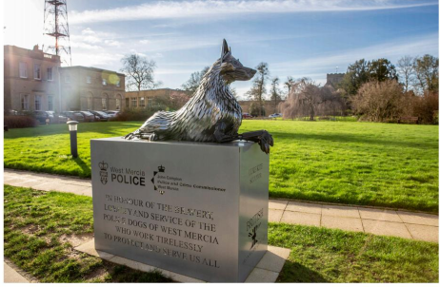  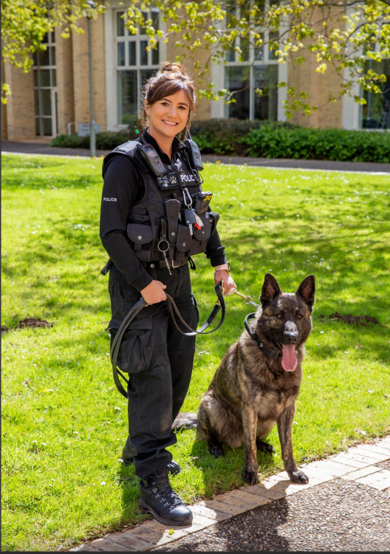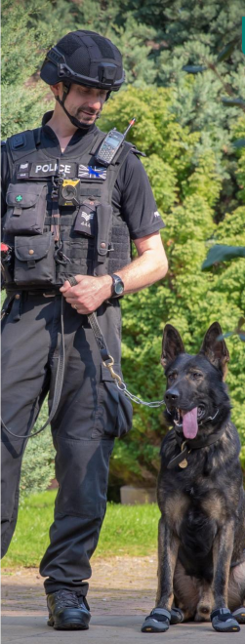 | Key Information:  Job title:  Salary:  What’s on offer?  Who we’re looking for?  Location:  Hours:  Duration:  How to apply: | Procurement Apprentice (Level 3) x 2  Starting at £18,159  - Full time, fixed-term contract leading to a professional qualification (Earn While You Learn).  - Fully funded Level 3 Apprenticeship in Commercial Procurement & Supply.  - Includes a Professional Development Plan to progress to management level, with an incremental higher salary.  - Develop a core set of transferable skills relevant to multiple industries.  - Level 2 qualified with a minimum Pass in English & Maths.  - Be good verbal and written communicators who enjoy speaking and providing good customer service.  - Have the resilience to handle difficult conversations and the curiosity to ask questions.  - A logical thinker interested in handling and interpreting data to come up with innovative solutions.  - Be able to prioritise and remain calm when dealing with multiple tasks.  - Have a right to work in the UK and have lived in the UK for the last 3 years.  Hindlip Hall, Hindlip, Worcester, WR3 8SP  It is expected that the Apprentices will primarily be based at Hindlip. However, there is flexibility to work out of local police stations.  37 hours per week (generally 9am – 5pm Monday – Friday)  Fixed term contract to the end of L3 studies, progressing into more senior roles subject to being awarded the Level 3 qualification and satisfactory performance.  Send a copy of your CV including personal details, education to-date and any work experience, with a cover letter including why you want to apply for the role, what you hope to gain from the Apprenticeship, what relevant knowledge, skills and understanding you can bring to the role and why you want to join the Police Service to  boc.staff.recruitment.team@westmercia.police.uk  Please use REF: PROC
